**ToCo Tools Core Orientation Operation Flowchart**

This initial doc describes ToCo tool operations with respect to Android Application program. It overviews the drilling operations and how they are linked to program functions. The flowchart is shown bellow.

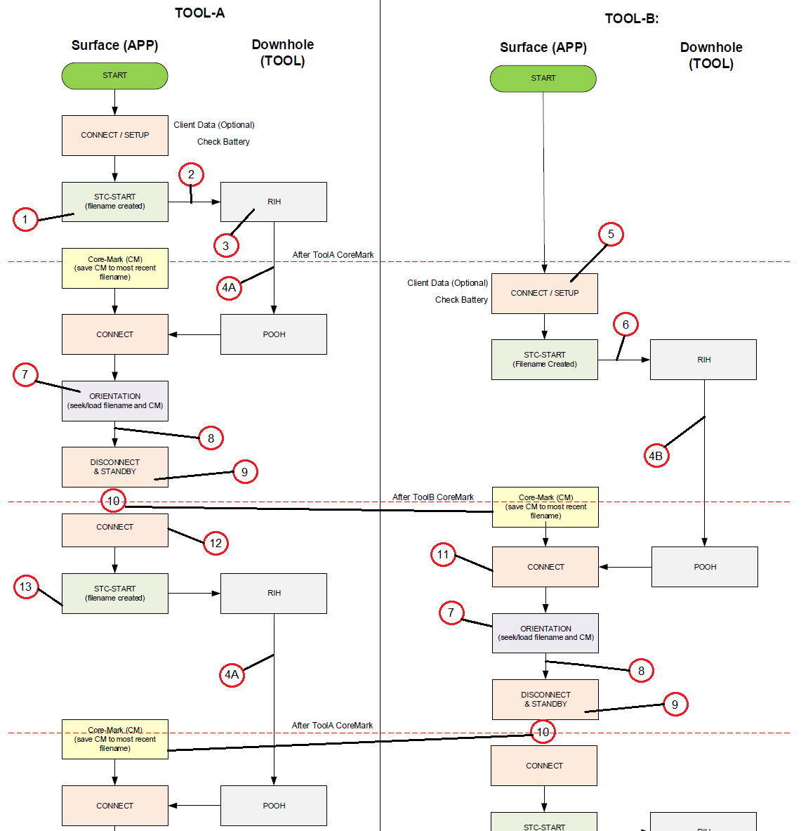

**1. ABBRAVIATIONS.**

AD – Android device

AAp – Android Application program

BH – Borehole

CoM – Core Marking

COri – Core Orientation during surface rotation of the ICB

ICB – Inner Core Barrel, part of the drilling tools, used to collect that core sample during drilling

InM – Inactive Mode, the tool is set to sleep mode in order to conserve/save battery capacity.

MEM – Memory of the ToCo tool

mTF – Mark Tool Face

oTF – Orientation Tool Face

STC – Start Time Clock?

SfM – Surface operation Mode

SRV – Survey operation mode

TA – Tool A

TB – Tool B

TSt – timestamp

RIH – Run In Hole

POOH – Pull Out Of Hole

**2. SOFTWARE OPERATIONS.**

The Core Orientation system consists of 2 ToCo tools, named Tool A and Tool B. The operations are simultaneous to some extend and are performed at the surface and in the earth (in the borehole) during drilling. At surface the tools operations are:

A. Workshop set up;

B. Rig site operation

* Surface operations
  + Setup
  + Start/Stop SRV mode
  + Core Orientation
  + Inactive Mode
* Downhole operations
  + Data frames logging (Read Sensor (Accel, temp., bats ….. Gyro is optional)

The AAp deals only with the rig site operations. Next is following explanation how the AAp reflects the drilling operations.

1. STC – START (create a file with specific name). The filename is the timestamp that is @ start when pressing button START RUN.
2. The TA is disconnected from the AD, assembled with the ICB and RIH
3. TA works autonomous and is logging data frames in its MEM.
4. (*) When TA is inside the BH borehole (during drilling) it stays there for a period of 30 to 150 min depending of the drilling advance/speed. Usually a core sample of 3,0 m is needed to fill the ICB and retrieved on surface. In this period AD can sleep or do another activities, but must be ready for marking the core. CoM is performed when drilling is stopped for 2-3 min and button MARK CORE is pressed. In this operation the AAp adds the resent TSt to the file generated for TA in STC – START (pressing the button START RUN).
5. AD/AAp is “waiting” or connected to TB, setup and disconnected ???? to be ready for operation while TA is “working” in the BH.
6. The TB is disconnected from the AD and RIH after TA is POOH.
7. TA is connected to AD and set to SfM. The logged data from TA MEM are read (This is 5 data frames “around” the timestamp when Core Mark button is pressed). With the 3rd (preferable data frame) the mTF is calculated and shown on screen of AD. For COri slow rotation is initiated and data frames are send from TA to AD. With the captured data the oTF is calculated and compare to the mTF.
8. When ABS(mTF – oTF) <= XY deg (the value of XY can be 0,5 or similar - this can be discussed) then the rotation is stopped. The free end of the core is marked with permanent pen – show on the picture.
9. The core orientation is confirmed with press button ORIENTATION DONE and TA is set to InM in order to save batteries life.
10. The AD/AAp can sleep or do another activities, but it has to be “ready” for core marking of TB. After the CoM is done the TB is POOH.
11. TB is connected to the AD and set to SfM operation, disconnected and put aside for COri procedures.
12. TA is connected and set to SRV operation mode, by pressing button START RUN.
13. The AD/AAp creates a new file with a name including the TSt and is disconnected and RIH. The tool works autonomous and is logging data frames in its MEM.
14. For TB all Step 7, 8, and 9 are repeated just the same as for TA. When ICB is filled with core sample the drilling operation are ceased and CoM is done. Then TA is POOH, connected, set to SfM, disconnected and put aside. Then TB that was set to InM in order to save batteries life is connected and set in SRV operation mode and RIH



**3. Revision 22/09-2020**

This revision includes the experience gained with the operation of ToCo tool CO – option. Included is the doc – WORK FLOW DIAGRAM for CORE ORIENTATION using 2 TOOLS-21-09-2020.docx with some additional comments and workflow diagram.

**3.1. WORK FLOW DIAGRAM for CORE ORIENTATION using 2 TOOLS**

This is IMPORTANT to be done exactly in this way. Richard Payne is not ALOWED to make any changes in this workflow.

This doc provides information about how core orientation is done in practice using 2 tools.

In the table below the step performed by the operator/driller are given. The col. Operations means that the operator is pressing button that appears on the screen of the AAp. This action operates/controls ToCo behavior by sending cmd or receiving data/info. Operation of the tool might be divided in 2 stages – onSurface and inBorehole.

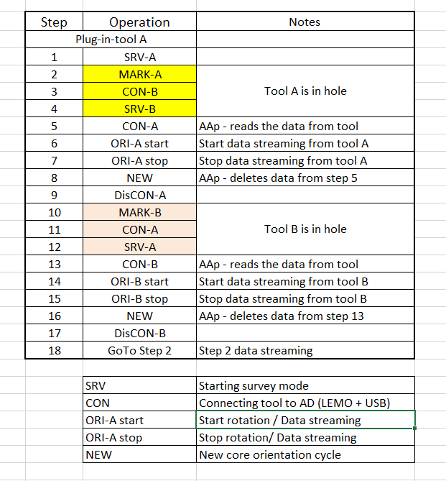

**3.1.1. onSurface.**

In this stage the tool-A/B is CON/DisCON to AAp. Here we have couple of “actions”. In CON state there is 2 options:

**1st – to start SRV**. Here the Aap sends the following cmds:

+EEISEMPTY(0x1)

+EEERASELOGDATA(0x5)

+RTCCHECK(0x3)

After it gets the correct response from the tool A/B it initiates the SRV mode by sending:

+STCSTART(0;” + timestamp + “)

**2nd – to Orient the marked core.** Here the tool is retrieved at the surface after being in the borehole (tool being in SRV mode) and the timestamp for marking is taken by the AAp. Here the Aap does:

+TLPHDATA(0xF0;0x” + Long.toHexString(timestamp).toUpperCase() + “)”

Orientation starts with tool steaming data to AAp by the command:

+TLPHSTART(0xFF)

To stop orientation the AAp sends:

+TLPHSTOP(0xFF)

**3.1.2. inBorehole.**

While in borehole tool A/B is running in SRV mode. The tool is saving DataFr in MEM for further use during core orientation at surface. This is all for this stage.

NOTES:

1. It is obvious that in Step 1, 4 and 12 after Tool-A/B is DisCON and RIH.
2. In steps 5 and 13 after CON, the AAp read automatically DataFr and RepFr.
3. In steps 9 and 17, the Tool-A/B is DisCON and CON again, just after the core of the Tool-B/A is marked and before running the tool in borehole.

**3.1.3. Workflow diagram.**

The WF diagram (figure 1) shows operation sequence and AAp logic with the specific commands send and respective response from the tool. It is assumed that the tool has uploaded FW, calibration matrix as well as rental period.

The AAp sense when the USB cable is plug-in and activates – **point 1**. Here the AAp reads the RepFr and check BAT state.

After pressing button Start the AAp sends commands as described in “**to start SRV**” – **point 2**.

Then the tool is DisCON and RIH – **point RIH**. The tools stays in hole until the inner tube is filled with core. When this is done the button Mark is pressed and the TSt is saved in the AAp (NO FILES are generated) for further reference.

At this point the operations and AAp logic split. The operations at the rig site is retrieving the inner tube - POOH, while the AAp starts the second tool (tool-B) – all the same sequence of activities as for the first tool. The second tool is DisCON and RIH immediately after the first (A) is retrieved.

After POOH tool-A and RIH tool-B ORI procedure with tool-A is initiated. The AAp sense CON and when tool connected AAp reads the DataFr by automatic sending a command with the TSt - as per above, included as a parameter of the command. The AAp waits for the response of the tool and after is got the DataFr requested it calculates the TF and Incl. and show them on screen. Then is ready for orientation procedure **point - 3**.

Core orientation starts with pressing a button. This action sends command as shown above and invokes DataFr streaming from the tool, while it is rotated in order to match TF. The AAp calculates only TF.

When the DTF gets = +/- 0,5 of the marked one while tool in hole, the operator halts rotation and pressed button to stop orientation – **point 4**.

After orientation is finished the AAp ask for a NEWRun. If confirmed the the AAp and operation follow the diagram flow/logic as shown in the figure 1 – **point 5**. Else the AAp stops.

NOTES:

1. The first run is always with the first tool – Tool-A.
2. The orientation cycle with the dual tools follows the diagram as shown A/B tool sequence.
3. The order of the tool cannot be mixed. The AAp check for CON the appropriate tool.
4. The AAp doesn’t use file system to save some parameters of operation data. The data is kept in the AD memory.
5. The AAp logic strictly follows the operation at the rig site during core operations. No changes, modifications or changes are allowed, since this is established practice in core drilling.
6. The AAp logic has been extensively tested and bugs, malfunction and problems haven’t been indentified.

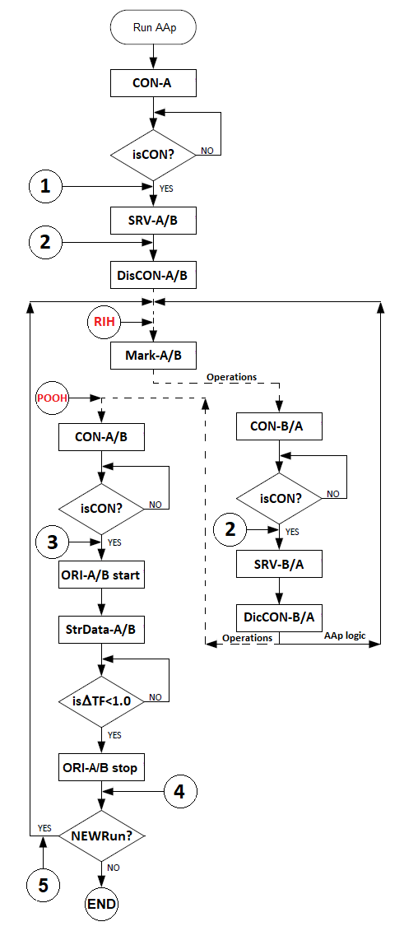

Figure 1. Workflow diagram for ToCo CO dual tools.